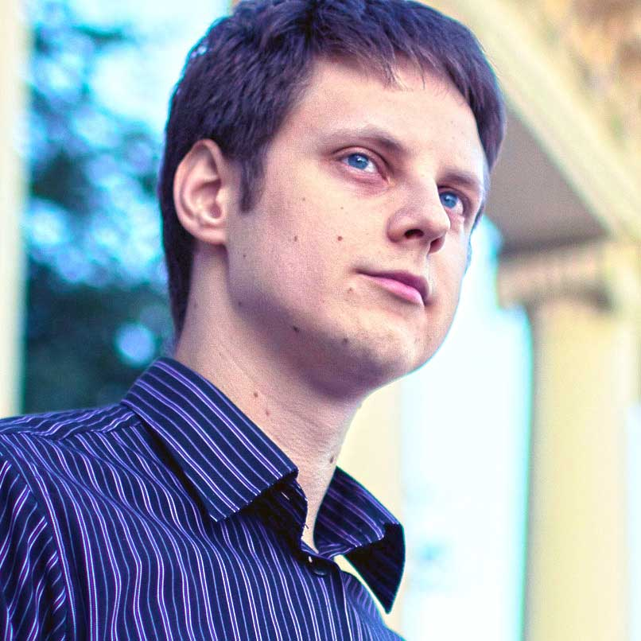Paul Radzkov

Senior front-end developer, UI designer

Location: Minsk, Belarus

Relocation: discussable

Age 30, Married

Phone: +375 29 552-73-41

Email: [radzkov@gmail.com](mailto:radzkov@gmail.com)

Skype: paulradzkov

Website: [paulradzkov.com](http://paulradzkov.com)

GitHub username: [interpaul](https://github.com/interpaul)

## About

## I became interested in web design in 2004. First as a freelance designer drew corporate websites for small firms, and then mastered HTML/CSS and started to make websites "turnkey". From 2005 to 2009 worked as the head of the Center of designing content in university. There I developed e-learning materials, created and maintained a website of the university, was engaged in the integration of web technologies into the learning process, was managing team of 3 members.

## Since 2009 until Nov 2013 I worked as a front-end developer in Belitsoft. I’ve been creating websites for Joomla, developing prototypes of interfaces for web applications and the company's products, graphic design. Since 2010 I am Team Lead and Head of Front-end department (up to 5 members).

## At November 2013 I moved to dedicated team of IDT Corporation as Executor Project lead. My current responsibilities: manage working activities with the team (2 UI designers and 2 Front-end developers), UI design and implementation, integration into .Net environment.

## I am interested in new trends in graphic design, typography, ergonomics and user interaction, infographics, business ideas, branding and identity.

## Before web development studied drawing (watercolor, graphics).

## Professional goals

To became a Full Stack Web Developer, to create products from concept to completed solution. I would like to be engaged into UI/UX, graphic design in near future. Later I’m going to improve my JavaScript skills.

## Tools and Technologies

HTML/CSS **expert**

Photoshop, Fireworks  **advanced**

JavaScript **intermediate** (creating UI elements)

PHP, Ruby, .Net, GIT, Node.js **basic** (run my personal blog at node.js platform)

English **intermediate** (not expecting problems in communications)

## Experience

**Responsive design** — Mobile First, Progressive Enhancement

**Prototyping of web applications** —UI/UX

**Front-end Development** — HTML/CSS/JavaScript, CMS templates

**Visual design** — Ads, collages, icons, graphic and brand design

**Project Management** —Managing team up to 5 members

## Education and Career

**2001—2006**   
Belarusian State Polytechnic University

Faculty of Information Technology and Robotics. Specialty — Robotics. Electrical engineering, Bachelor of Engineering.

**Oct 2004 — Sept 2009**Moscow State University of Economics, Statistics and Informatics (department in Minsk)

*Oct 2004* — *Nov 2005* — Part-time System Administrator

*Nov 2005* — *Sept 2009* — Head of the Center of designing content

**Oct 2009 — nowadays**Belitsoft ([belitsoft.com](http://belitsoft.com/))

*Oct 2009 — June 2010* — Front-end developer

*July 2010 — Nov 2013* — Senior front-end developer, Team Lead

**Projects inside Belitsoft:**

*Apr 2011 — Nov 2013* —Part-time Front-end developer and graphic designer at [Fishpond](http://www.fishpond.co.nz/) (New Zealand, Australia)

*Apr — July 2013 —* Part-time Front-end developer at [Monterossa](http://www.monterosa.co.uk/) (UK)

*Nov 2013 — nowadays —* Full-time Executor Project lead at [IDT Corporation](http://www.idt.net/) (USA)

## Projects

<http://elearningsoft.ru>  
Wireframes, visual design, HTML/CSS, CMS integration (Joomla), content management.

<http://dev.paulradzkov.com/edu-tpp/>  
Design, Flash, HTML/CSS/JS.

<http://dev.paulradzkov.com/protennis/>   
HTML/CSS/JS.

<http://dev.paulradzkov.com/idt/CalaFeedback/>   
Design, implementation and integration (.net). This is static prototype; use any username, any password to log in. [Code](https://github.com/interpaul/CalaFeedbackUI) on github

<http://dev.paulradzkov.com/callgenius/>   
Bootstrap UI prototypes.

<http://paulradzkov.com/>   
My blog about web-dev. [Code](https://github.com/interpaul/paulradzkov.com) on github.

More [Designs](https://plus.google.com/photos/115202814477140711940/albums/5940578125144176177), [Drawings](https://plus.google.com/photos/115202814477140711940/albums/5116721164920612593), [Prototypes](http://dev.paulradzkov.com/), [Code](https://github.com/interpaul).